
UNIVERSITY OF FRONTIER TECHNOLOGY, BANGLADESH
Department of Cyber Security Engineering

Lab Report

Name of the Experiment: Windows-Log-Analysis-with-PowerShell
Course Code: SEC204
Course Title: Threat Modeling and Security Monitoring Sessional

Submitted by,  Name: Mst.Bithi Khatun  ID: 2404024  Level – 02, Term – 01  Session: 2024-2025 | Submitted to,  MD.Masud Rana  Lecturer,  Department of Cyber Security Engineering

1. Objective
The purpose of this lab is to use PowerShell to read and analyse the Windows Security event log and to link what is found to threat-modeling concepts. The lab shows how to detect failed logons, brute-force patterns, use of explicit credentials, file-share access, group-membership changes and privileged logons, and how to combine these checks into one automated script and export the results as evidence.

2. Introduction
Threat modeling identifies what can go wrong in a system and how to detect or prevent it. The STRIDE model groups threats as Spoofing, Tampering, Repudiation, Information disclosure, Denial of service and Elevation of privilege. Windows records security-relevant activity in the Security event log, and each event ID corresponds to an observable behaviour that an analyst can search for with Get-WinEvent.
Event IDs used in this lab
Event ID | Meaning | Threat relevance
4624 | Account successfully logged on | Baseline of normal authentication
4625 | Account failed to log on | Password guessing / brute force (Spoofing)
4648 | Logon with explicit credentials | Lateral movement, runas (Elevation of privilege)
4672 | Special privileges assigned to new logon | Privileged account use
4732 | Member added to local security group | Persistence / privilege escalation
4798 | User's local group membership enumerated | Reconnaissance
5140 | Network share object accessed | Information disclosure

3. Lab Environment
Windows 11 workstation named FARIYA, workgroup configuration, Windows PowerShell 5.1 opened as Administrator (required to read the Security log). Auditing for failed logons was enabled with auditpol /set /subcategory:"Logon" /failure:enable. All commands below are shown with their output as captured in the PowerShell console.

4. Tasks, Commands and Results
Each task lists the objective, the command (document type: PowerShell script), the console output, and an analysis with the related STRIDE category.

Task 1: Check the PowerShell Version
Objective: Confirm the PowerShell engine version available on the lab machine before running any log-analysis commands.
Command (PowerShell):$PSVersionTable.PSVersion

Screenshot - Figure 1: Check the PowerShell Version
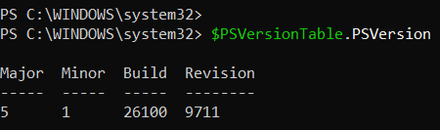
Analysis: The lab machine runs Windows PowerShell 5.1 (build 26100.9711). Get-WinEvent with -FilterHashtable is supported in this version, so all later commands are compatible.
Threat-model link: Preparation - environment baseline

Task 2: Set Execution Policy and Read Security Log
Objective: Allow locally written scripts to run (RemoteSigned for the current user) and retrieve the 10 newest events from the Security log.
Command (PowerShell):
Set-ExecutionPolicy -ExecutionPolicy RemoteSigned -Scope CurrentUser
Get-WinEvent -LogName Security -MaxEvents 10

Screenshot - Figure 2: Set Execution Policy and Read Security Log
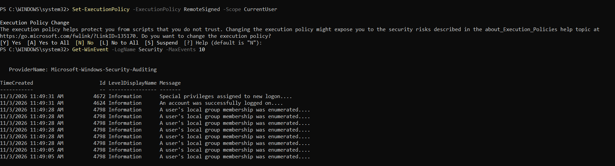
Analysis: RemoteSigned lets local scripts run while requiring a signature for scripts downloaded from the internet, which reduces the risk of running untrusted code. The newest Security events are logon (4624), special privileges (4672) and group enumeration (4798).
Threat-model link: Tampering / Elevation of Privilege - control: script execution policy

Task 3: Filter Successful Logons (Event ID 4624)
Objective: Use -FilterHashtable to retrieve only successful logon events, which is faster than filtering after retrieval.
Command (PowerShell):
Get-WinEvent -FilterHashtable @{LogName='Security'; ID=4624} -MaxEvents 20

Screenshot - Figure 3: Filter Successful Logons (Event ID 4624)
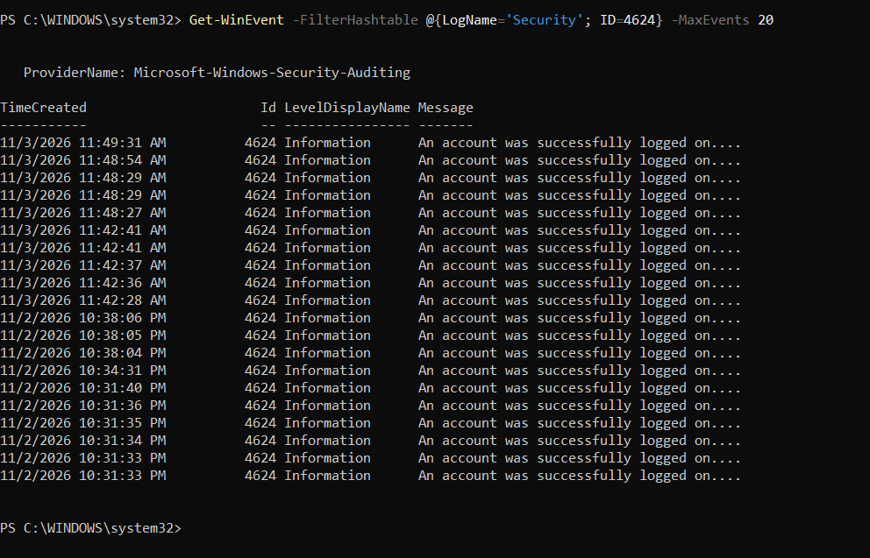
Analysis: Twenty successful logons were returned, spanning 11/2/2026 10:31 PM to 11/3/2026 11:49 AM. Baselining normal logon activity is the first step in spotting anomalies.
Threat-model link: Spoofing - detecting unexpected authentication

Task 4: Format Logon Events as a Table
Objective: Display only the fields that matter (time, ID, message) in a compact table.
Command (PowerShell):
Get-WinEvent -FilterHashtable @{LogName='Security'; ID=4624} -MaxEvents 20 |
Select-Object TimeCreated, Id, Message |
Format-Table -AutoSize

Screenshot - Figure 4: Format Logon Events as a Table
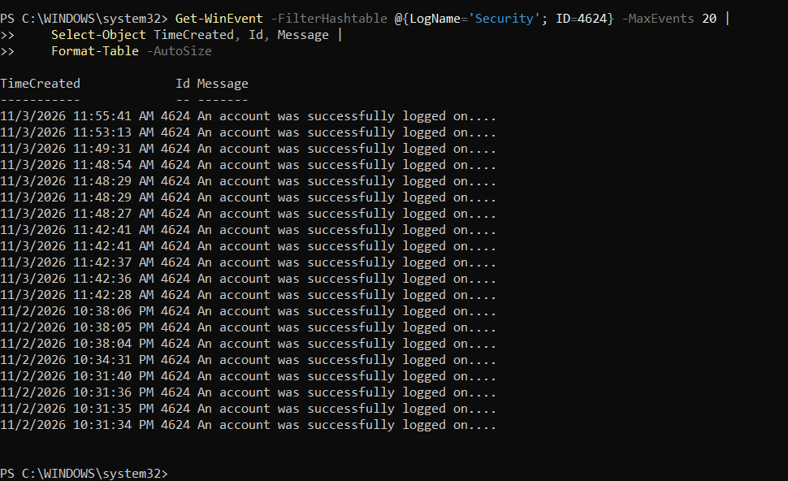
Analysis: Select-Object and Format-Table -AutoSize give a cleaner view for reports. The message is truncated in the table, so detailed fields need Format-List or XML parsing (shown in later tasks).
Threat-model link: Repudiation - building an audit trail

Task 5: Query Events from the Last 24 Hours
Objective: Restrict the query with a StartTime so only recent events are returned.
Command (PowerShell):
$StartTime = (Get-Date).AddDays(-1)
Get-WinEvent -FilterHashtable @{
LogName='Security'
StartTime=$StartTime
} -MaxEvents 100

Screenshot - Figure 5: Query Events from the Last 24 Hours
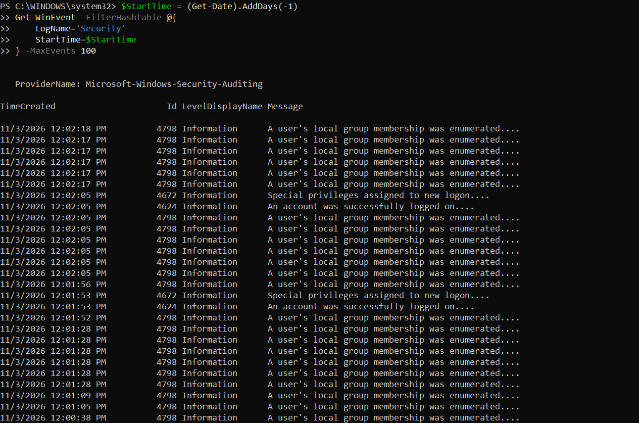
Analysis: A time window narrows the investigation. Each logon (4624) is accompanied by a special-privileges event (4672) and several group-enumeration events (4798).
Threat-model link: Information Disclosure - monitoring access to account data

Task 6: Review Group Enumeration Events (Event ID 4798)
Objective: Inspect the volume of local group membership enumeration events in the previous output.
Command (PowerShell):
# continuation of the previous query (-MaxEvents 100)

Screenshot - Figure 6: Review Group Enumeration Events (Event ID 4798)
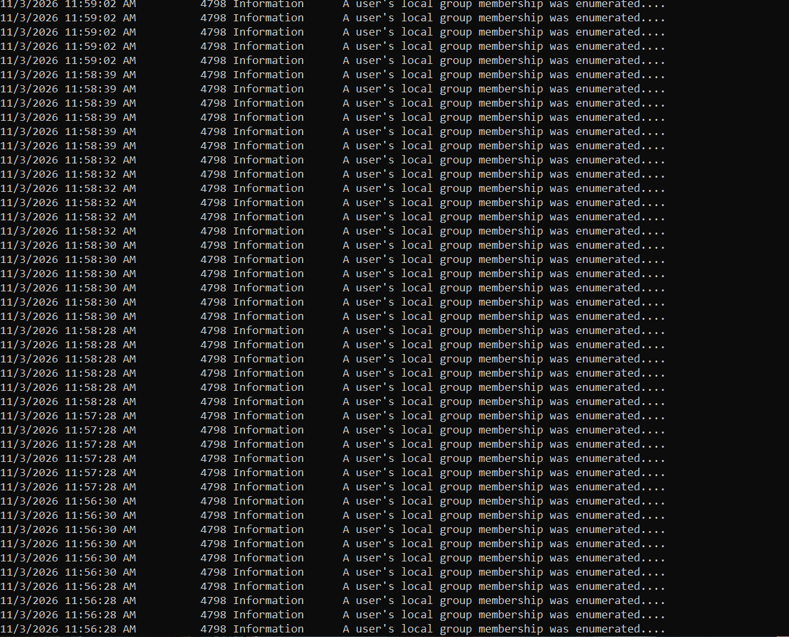
Analysis: Event 4798 appears in large numbers in short bursts. This is normal Windows background behaviour, but attackers also enumerate groups during reconnaissance, so the baseline is important to tell the two apart.
Threat-model link: Information Disclosure / Reconnaissance

Task 7: Query Failed Logons (Event ID 4625)
Objective: Find failed logon attempts, a primary indicator of password guessing.
Command (PowerShell):
Get-WinEvent -FilterHashtable @{
LogName = 'Security'
Id = 4625
} -MaxEvents 10

Screenshot - Figure 7: Query Failed Logons (Event ID 4625)
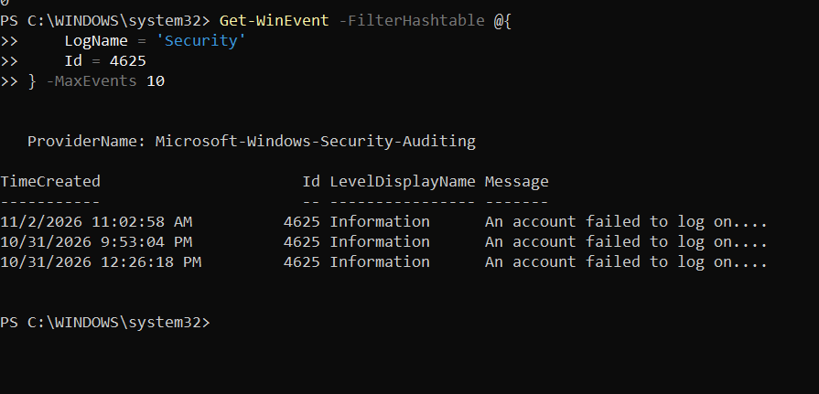
Analysis: Three failed logons were found in the log (10/31 and 11/2). Low counts like this are typical of mistyped passwords rather than an attack.
Threat-model link: Spoofing / Brute force - credential guessing

Task 8: Inspect a Failed Logon in Full Detail
Objective: Read all fields of the newest 4625 event with Format-List *.
Command (PowerShell):
$Event = Get-WinEvent -FilterHashtable @{LogName='Security'; ID=4625} -MaxEvents 1
$Event | Format-List *

Screenshot - Figure 8: Inspect a Failed Logon in Full Detail
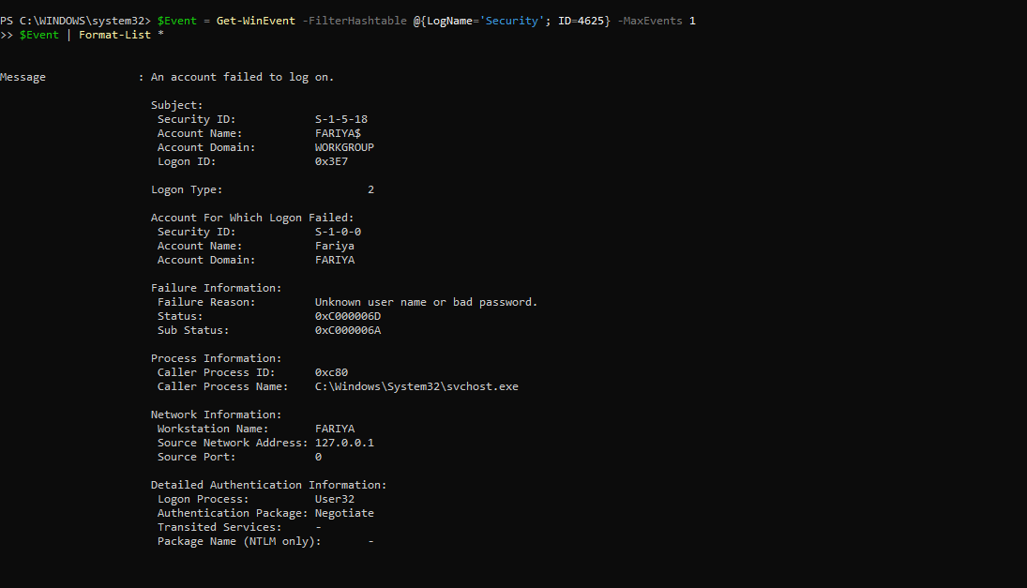
Analysis: Logon Type 2 means an interactive (keyboard) logon. Sub-status 0xC000006A means the user name exists but the password was wrong. The source is 127.0.0.1, so the attempt came from the local machine itself.
Threat-model link: Spoofing - failed authentication analysis

Task 9: Parse Event Properties into Custom Objects
Objective: Extract only the useful fields (target user, source IP, logon type, failure reason) from the event properties array.
Command (PowerShell):
Get-WinEvent -FilterHashtable @{LogName='Security'; ID=4625} -MaxEvents 10 |
ForEach-Object {
[PSCustomObject]@{
TimeCreated = $_.TimeCreated
TargetUser = $_.Properties[5].Value
SourceIP = $_.Properties[19].Value
LogonType = $_.Properties[8].Value
FailureReason = $_.Properties[13].Value
}
} | Format-Table -AutoSize

Screenshot - Figure 9: Parse Event Properties into Custom Objects
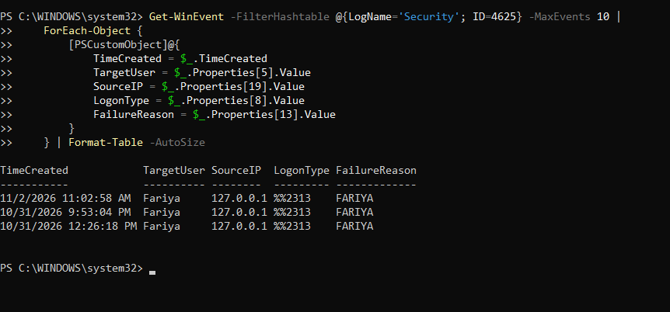
Analysis: Parsing the Properties array gives structured output suitable for filtering and export. The FailureReason column shows the domain name (FARIYA) instead of a text reason, which indicates the property index is off by one for this event layout; the XML approach used in later tasks is more reliable because it addresses fields by name.
Threat-model link: Repudiation - structured audit data

Task 10: Enable Failed Logon Auditing and Search the Last 24 Hours
Objective: Make sure failed logons are audited with auditpol, then search the last 24 hours and print the count.
Command (PowerShell):
auditpol /set /subcategory:"Logon" /failure:enable
$StartTime = (Get-Date).AddDays(-1)
$FailedLogons = Get-WinEvent -FilterHashtable @{
LogName = 'Security'
Id = 4625
StartTime = $StartTime
} -ErrorAction SilentlyContinue
if ($FailedLogons) {
Write-Host "Total Failed Logins:" $FailedLogons.Count
$FailedLogons | Select-Object TimeCreated, Id, Message | Format-List
}
else {
Write-Host "No Failed Login Events Found in Last 24 Hours."
}

Screenshot - Figure 10: Enable Failed Logon Auditing and Search the Last 24 Hours
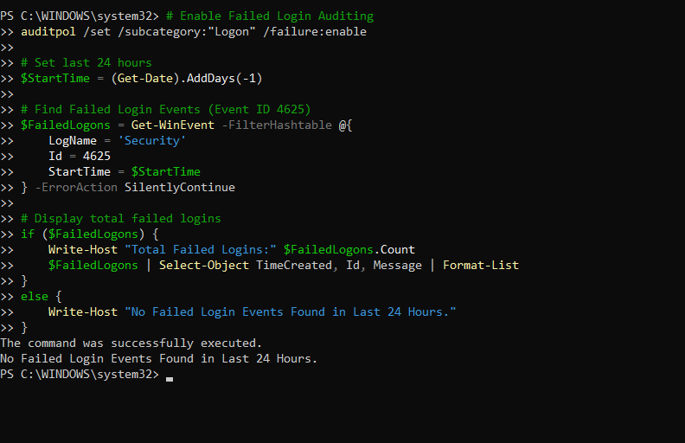
Analysis: Auditing for failed logons is enabled. -ErrorAction SilentlyContinue prevents an error when no events match. At that moment no failure was recorded yet in the 24-hour window.
Threat-model link: Repudiation - enabling audit policy

Task 11: Display Details of Collected Failed Logons
Objective: After generating a failed logon, print the stored events in list form.
Command (PowerShell):
$FailedLogons | Format-List TimeCreated, Id, Message

Screenshot - Figure 11: Display Details of Collected Failed Logons
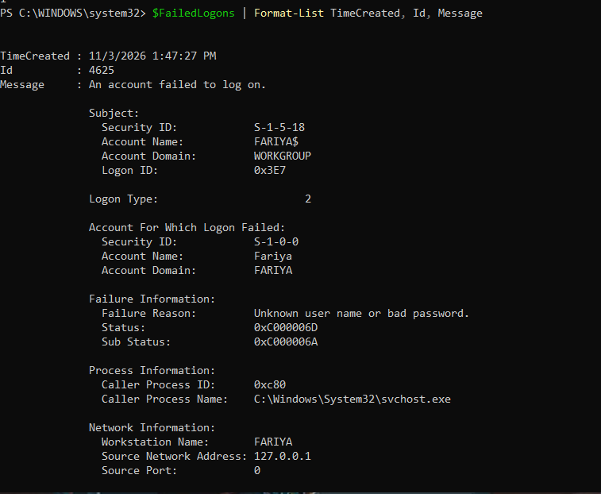
Analysis: A failed interactive logon was recorded at 1:47:27 PM, showing that auditing now captures new failures correctly.
Threat-model link: Spoofing - verification of audit capture

Task 12: Detect Possible Brute-Force Attacks by Source IP
Objective: Group failed logons by source IP and flag any address that reaches a threshold of failures.
Command (PowerShell):
$SuspiciousIPs = $FailedLogons |
Where-Object { $_.SourceIP -ne '-' -and $_.SourceIP -ne $null -and $_.SourceIP -ne '' } |
Group-Object SourceIP |
Where-Object { $_.Count -ge $FailureThreshold } |
Sort-Object Count -Descending

Write-Host "`n=== POTENTIAL BRUTE-FORCE ATTACKS DETECTED ===" -ForegroundColor Red
Write-Host "Time Window: Last 1 hour" -ForegroundColor Yellow
Write-Host "Threshold: $FailureThreshold failed attempts`n" -ForegroundColor Yellow

if ($SuspiciousIPs.Count -gt 0) {
foreach ($IP in $SuspiciousIPs) {
Write-Host "Source IP: $($IP.Name)" -ForegroundColor Red
Write-Host "Failed Attempts: $($IP.Count)" -ForegroundColor Red
Write-Host "Targeted Accounts:" -ForegroundColor Yellow
$IP.Group | Select-Object -ExpandProperty TargetUser -Unique |
ForEach-Object { Write-Host " - $_" }
Write-Host ""
}
}
else {
Write-Host "No Potential Brute-Force Activity Detected." -ForegroundColor Green
}

Screenshot - Figure 12: Detect Possible Brute-Force Attacks by Source IP
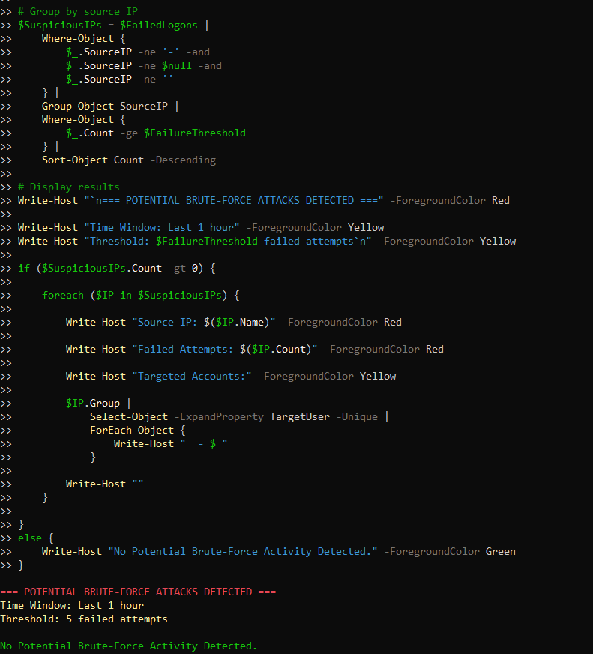
Analysis: The detection rule uses a threshold of 5 failures within one hour from the same IP. No address reached the threshold, so no brute-force activity was detected. The banner prints before the result, so the final line is what decides the outcome.
Threat-model link: Spoofing / Denial of Service - brute-force detection rule

Task 13: Simulate a Failed Network Logon (FakeUser) and Read It
Objective: Generate a failed logon for a non-existent account and read it back for the last 5 minutes to validate the detection pipeline.
Command (PowerShell):
Get-WinEvent -FilterHashtable @{
LogName='Security'
ID=4625
StartTime=(Get-Date).AddMinutes(-5)
} | Select-Object TimeCreated, Message | Format-List

Screenshot - Figure 13: Simulate a Failed Network Logon (FakeUser) and Read It
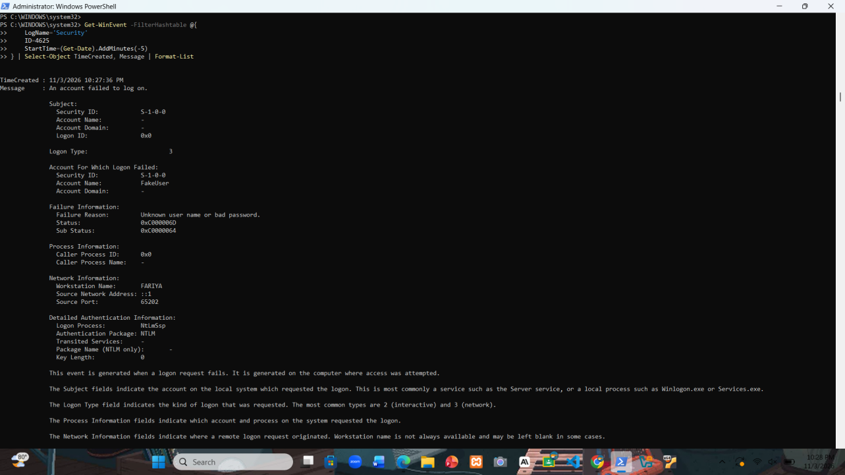
Analysis: Logon Type 3 is a network logon over NTLM. Sub-status 0xC0000064 means the user name does not exist, which is different from 0xC000006A (wrong password). Attackers guessing user names produce this signature. The source ::1 is the IPv6 loopback address, confirming the test was local.
Threat-model link: Spoofing - user enumeration / password guessing

Task 14: Detect Explicit Credential Use (Event ID 4648)
Objective: List logons made with explicitly supplied credentials in the last 24 hours, which can indicate lateral movement or runas activity.
Command (PowerShell):
Get-WinEvent -FilterHashtable @{
LogName='Security'
ID=4648
StartTime=(Get-Date).AddDays(-1)
} | ForEach-Object {
$xml = [xml]$_.ToXml()
[PSCustomObject]@{
TimeCreated = $_.TimeCreated
SourceUser = $xml.Event.EventData.Data[1].'#text'
TargetUser = $xml.Event.EventData.Data[5].'#text'
TargetServer = $xml.Event.EventData.Data[8].'#text'
Process = $xml.Event.EventData.Data[11].'#text'
}
} | Format-Table -AutoSize

Screenshot - Figure 14: Detect Explicit Credential Use (Event ID 4648)
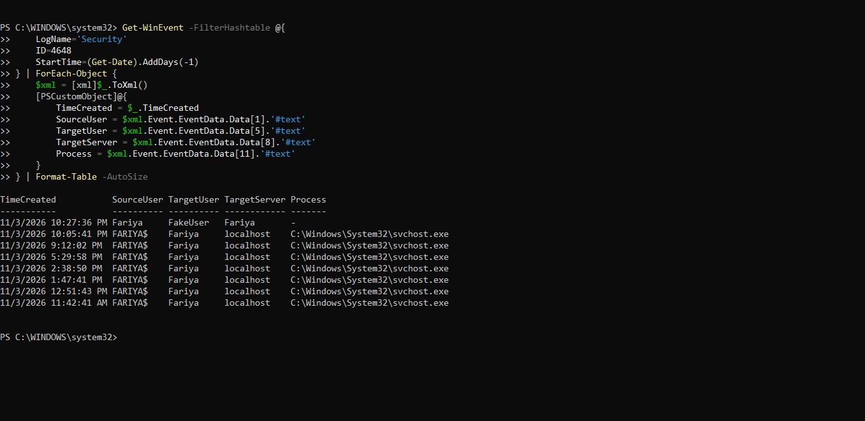
Analysis: Eight explicit-credential events were found. The first (10:27:36 PM) is the simulated FakeUser attempt made by Fariya and stands out because the process field is empty. The other seven are normal system activity from svchost.exe on localhost.
Threat-model link: Elevation of Privilege / Lateral movement

Task 15: Monitor File Share Access (Event ID 5140)
Objective: Check whether any network share was accessed in the last hour by reading event 5140 data fields by name.
Command (PowerShell):
$StartTime = (Get-Date).AddHours(-1)
$Events = @(Get-WinEvent -FilterHashtable @{
LogName = 'Security'
ID = 5140
StartTime = $StartTime
} -ErrorAction SilentlyContinue)

if ($Events.Count -gt 0) {
$Events | ForEach-Object {
$xml = [xml]$_.ToXml()
$Data = @{}
foreach ($item in $xml.Event.EventData.Data) { $Data[$item.Name] = $item.'#text' }
[PSCustomObject]@{
TimeCreated = $_.TimeCreated
Account = "$($Data['SubjectDomainName'])\$($Data['SubjectUserName'])"
SourceIP = $Data['IpAddress']
ShareName = $Data['ShareName']
}
} | Format-Table -AutoSize
}
else {
Write-Host "No Event ID 5140 found in the last 1 hour." -ForegroundColor Yellow
}

Screenshot - Figure 15: Monitor File Share Access (Event ID 5140)
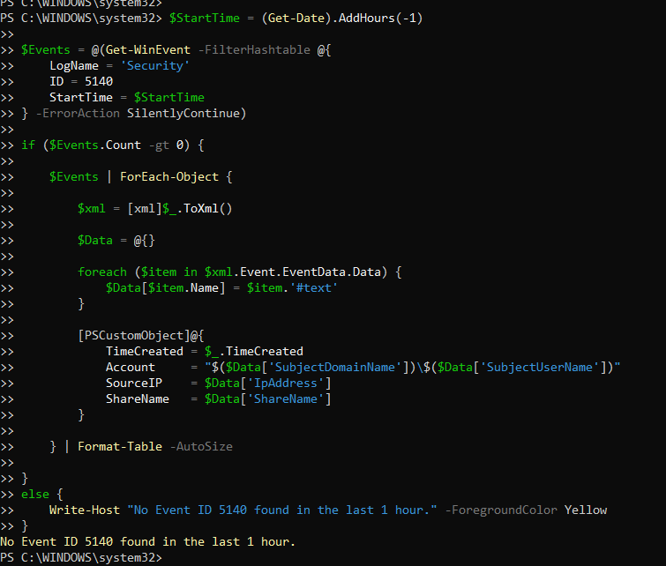
Analysis: No network share access occurred. Reading fields by name (Data['IpAddress']) is more robust than numeric indexes.
Threat-model link: Information Disclosure - unauthorised share access

Task 16: Detect Users Added to Security Groups (Event ID 4732)
Objective: Check for accounts added to a local security group in the last 7 days, a common persistence/privilege-escalation step.
Command (PowerShell):
$StartTime = (Get-Date).AddDays(-7)
$Events = @(Get-WinEvent -FilterHashtable @{
LogName = 'Security'
ID = 4732
StartTime = $StartTime
} -ErrorAction SilentlyContinue)

if ($Events.Count -gt 0) {
$Events | ForEach-Object {
$xml = [xml]$_.ToXml()
$Data = @{}
foreach ($item in $xml.Event.EventData.Data) { $Data[$item.Name] = $item.'#text' }
[PSCustomObject]@{
TimeCreated = $_.TimeCreated
AddedUser = $Data['MemberName']
GroupName = $Data['TargetUserName']
AddedBy = $Data['SubjectUserName']
}
} | Format-Table -AutoSize
}
else {
Write-Host "No Event ID 4732 found in the last 7 days." -ForegroundColor Yellow
}

Screenshot - Figure 16: Detect Users Added to Security Groups (Event ID 4732)
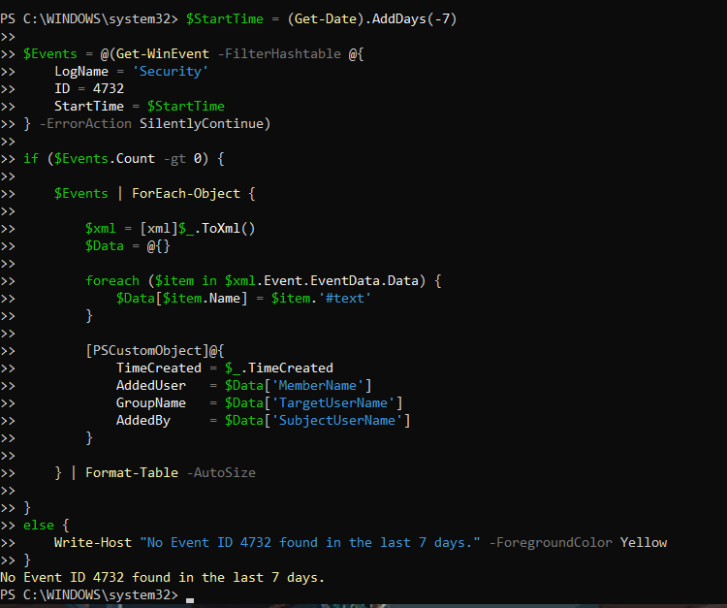
Analysis: No user was added to any security group during the week, so no privilege-escalation through group changes was detected.
Threat-model link: Elevation of Privilege - group membership changes

Task 17: Review Special Privilege Logons (Event ID 4672)
Objective: List special-privilege logons for the last hour and filter out machine accounts ending in $.
Command (PowerShell):
Get-WinEvent -FilterHashtable @{
LogName='Security'
ID=4672
StartTime=(Get-Date).AddHours(-1)
} | ForEach-Object {
$xml = [xml]$_.ToXml()
[PSCustomObject]@{
TimeCreated = $_.TimeCreated
Account = $xml.Event.EventData.Data[1].'#text'
LogonID = $xml.Event.EventData.Data[3].'#text'
}
} | Where-Object { $_.Account -notlike '*$' } | # Filter out system accounts
Format-Table -AutoSize

Screenshot - Figure 17: Review Special Privilege Logons (Event ID 4672)
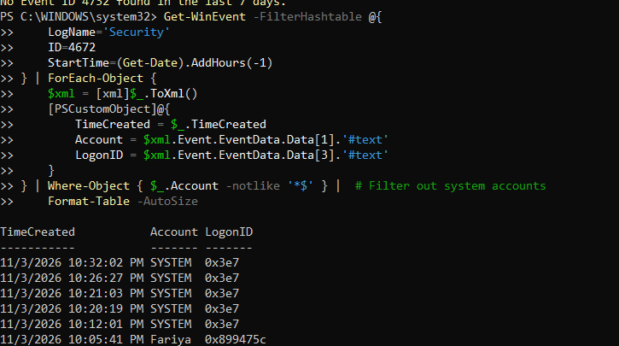
Analysis: Most privileged logons belong to SYSTEM (logon ID 0x3e7), which is expected. The one user entry (Fariya, 10:05:41 PM) is an administrator sign-in. Any unfamiliar account here should be investigated.
Threat-model link: Elevation of Privilege - privileged logon monitoring

Task 18: Build a Comprehensive Security Log Analysis Script (Part 1)
Objective: Combine the individual checks into one reusable script with an -Hours parameter. This part defines the parameter, header and failed/successful logon analysis.
Command (PowerShell):
<#
.SYNOPSIS
Comprehensive Windows Security Log Analysis Script
.DESCRIPTION
Analyzes Windows Security Event Logs for suspicious activity
.PARAMETER Hours
Number of hours to analyze (default: 24)
.EXAMPLE
.\Analyze-SecurityLogs.ps1 -Hours 24
#>
param(
[int]$Hours = 24
)

$StartTime = (Get-Date).AddHours(-$Hours)

Write-Host "Windows Security Log Analysis Report" -ForegroundColor Cyan
Write-Host "Analysis Period: Last $Hours hours" -ForegroundColor Yellow
Write-Host "Start Time: $StartTime" -ForegroundColor Yellow

# 1. Failed Logon Analysis
$FailedLogons = Get-WinEvent -FilterHashtable @{
LogName='Security'; ID=4625; StartTime=$StartTime
} -ErrorAction SilentlyContinue

if ($FailedLogons) {
Write-Host "Total Failed Logons: $($FailedLogons.Count)" -ForegroundColor Yellow
Write-Host "`nTop 5 Source IPs:" -ForegroundColor Cyan
$FailedLogons | ForEach-Object { $_.Properties[19].Value } |
Where-Object { $_ -ne '-' } |
Group-Object | Sort-Object Count -Descending | Select-Object -First 5 |
Format-Table @{Name='IP Address';Expression={$_.Name}}, @{Name='Attempts';Expression={$_.Count}} -AutoSize

Write-Host "Top 5 Targeted Accounts:" -ForegroundColor Cyan
$FailedLogons | ForEach-Object { $_.Properties[5].Value } |
Where-Object { $_ -ne '-' } |
Group-Object | Sort-Object Count -Descending | Select-Object -First 5 |
Format-Table @{Name='Username';Expression={$_.Name}}, @{Name='Attempts';Expression={$_.Count}} -AutoSize
} else {
Write-Host "No failed logons found." -ForegroundColor Green
}

# 2. Successful Logon Analysis
$SuccessfulLogons = Get-WinEvent -FilterHashtable @{
LogName='Security'; ID=4624; StartTime=$StartTime
} -ErrorAction SilentlyContinue

if ($SuccessfulLogons) { ... }

Screenshot - Figure 18: Build a Comprehensive Security Log Analysis Script (Part 1)
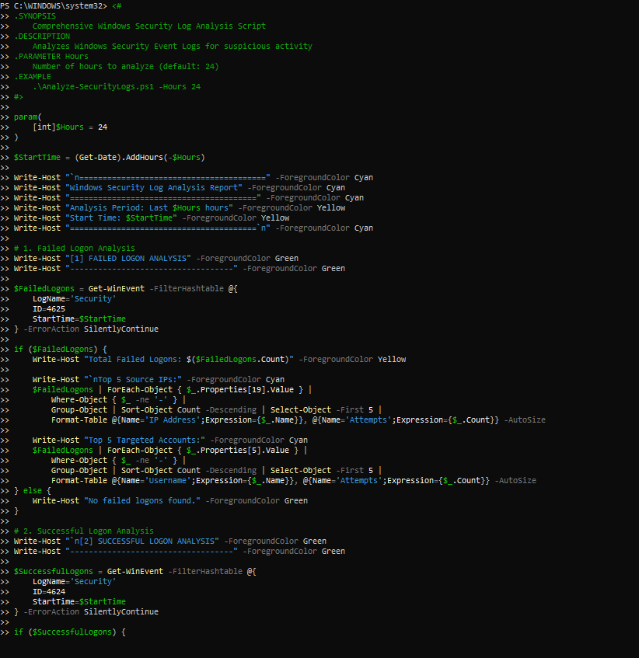
Analysis: The script uses a [int]$Hours parameter so the same analysis can cover any time window. It reports the top source IPs and targeted accounts, which are the two key indicators of password attacks. Sections 3 (account management) and 4 (privilege indicators) follow the same pattern.
Threat-model link: All STRIDE categories - automated detection

Task 19: Run the Security Log Analysis Script
Objective: Execute the script for the last 24 hours and review the consolidated report.
Command (PowerShell):
.\Analyze-SecurityLogs.ps1 -Hours 24

Screenshot - Figure 19: Run the Security Log Analysis Script
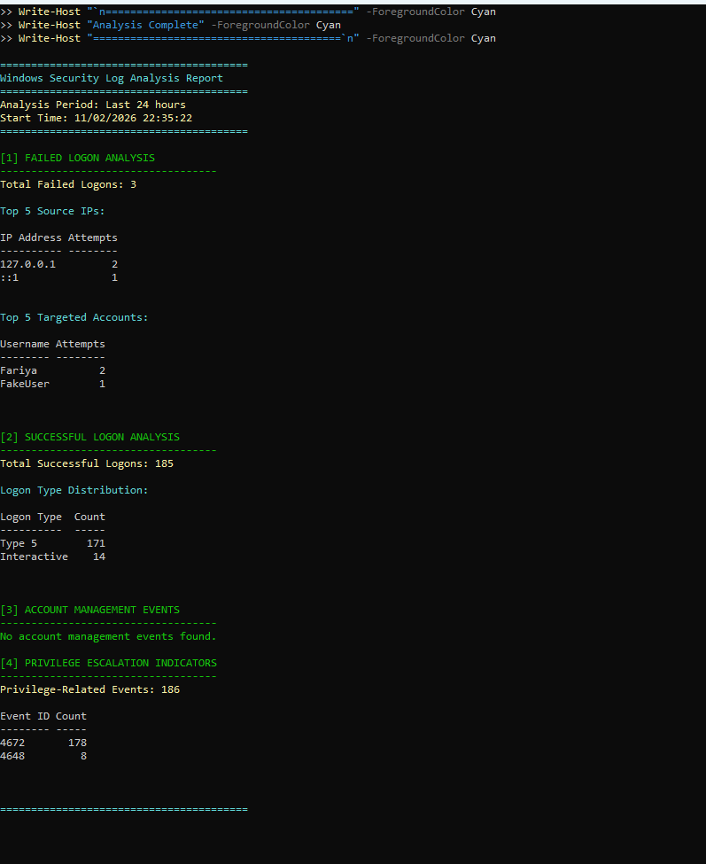
Analysis: In 24 hours there were 3 failed logons (all from the local loopback addresses), 185 successful logons (171 service logons of type 5 and 14 interactive), no account-management changes, and 186 privilege-related events. Nothing indicates an external attack; the only suspicious-looking item is the deliberate FakeUser test.
Threat-model link: Summary / risk assessment

Task 20: Export Failed Logons to CSV and HTML
Objective: Create reports that can be shared or attached to an incident record.
Command (PowerShell):
# CSV export
Get-WinEvent -FilterHashtable @{
LogName='Security'
ID=4625
StartTime=(Get-Date).AddDays(-1)
} | ForEach-Object {
[PSCustomObject]@{
TimeCreated = $_.TimeCreated
SourceIP = $_.Properties[19].Value
TargetUser = $_.Properties[5].Value
LogonType = $_.Properties[8].Value
FailureReason = $_.Properties[13].Value
}
} | Export-Csv -Path "FailedLogons.csv" -NoTypeInformation
Write-Host "Exported to FailedLogons.csv"

# HTML export
$FailedLogons = Get-WinEvent -FilterHashtable @{
LogName='Security'; ID=4625; StartTime=(Get-Date).AddDays(-1)
} | ForEach-Object {
[PSCustomObject]@{
TimeCreated = $_.TimeCreated
SourceIP = $_.Properties[19].Value
TargetUser = $_.Properties[5].Value
LogonType = $_.Properties[8].Value
}
}
$HTML = $FailedLogons | ConvertTo-Html -Title "Failed Logon Report" `
-PreContent "<h1>Failed Logon Analysis</h1><p>Generated: $(Get-Date)</p>"
$HTML | Out-File "FailedLogons.html"
Write-Host "Exported to FailedLogons.html"

Screenshot - Figure 20: Export Failed Logons to CSV and HTML
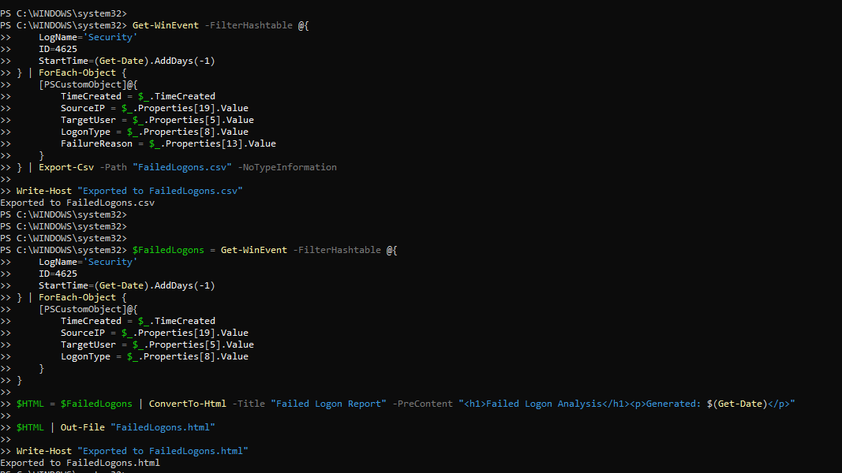
Analysis: Both reports were created in the working directory. CSV suits spreadsheets and SIEM import; HTML suits readable evidence for management or an incident ticket.
Threat-model link: Repudiation - evidence preservation

5. Summary of Findings
Area | Finding | Risk
Failed logons (4625) | 3 in 24 h; all from 127.0.0.1 / ::1; accounts Fariya (2) and FakeUser (1, simulated test) | Low
Brute force | No source IP reached the 5-attempt threshold | Low
Successful logons (4624) | 185 in 24 h: 171 service (type 5), 14 interactive | Normal
Explicit credentials (4648) | 8 events; 7 routine svchost.exe, 1 deliberate FakeUser test | Low
Share access (5140) | None in the last hour | None
Group changes (4732) | None in the last 7 days | None
Privileged logons (4672) | 178 in 24 h; user-level entry is administrator Fariya | Expected

6. Recommendations (Mitigations)
- Keep failed-logon auditing enabled and review event 4625 regularly.
- Use an account lockout policy (for example, lock after 5 failed attempts) to slow password guessing.
- Use strong passwords or passphrases and multi-factor authentication where available.
- Alert on any 4732 event and on 4672 events for non-administrative accounts.
- Keep the execution policy at RemoteSigned or stricter and run analysis scripts only from trusted sources.
- Forward logs to a central location so evidence cannot be erased by an attacker on the local machine.

7. Conclusion
PowerShell and Get-WinEvent make it practical to turn raw Security log entries into evidence for threat modeling. Through 20 tasks the lab built queries from simple event retrieval to a full automated analysis script, and produced CSV and HTML reports. The only suspicious event found was the simulated FakeUser logon, which was detected correctly (event 4625 with sub-status 0xC0000064), showing that the detection approach works. The machine showed no sign of real compromise during the analysis period.

